Cutting tool modeling practice
Version 0.4
Contents
Cutting tool data example 2
Assembly 2
Holder 2
Tool sub-assembly 3
Tool body 3
Cutting insert 4
Insert screw 4
Retention knob 4
Cutting tool classification 5
Assembly structure 5
Tool classification 5
General property 5
Dimension property 6
Feature classification 6
General feature representation 6
Feature classification 7
Structure of class and property representation 8
Class hierarchy 8
Property name scope 8

Cutting tool data example

Assembly
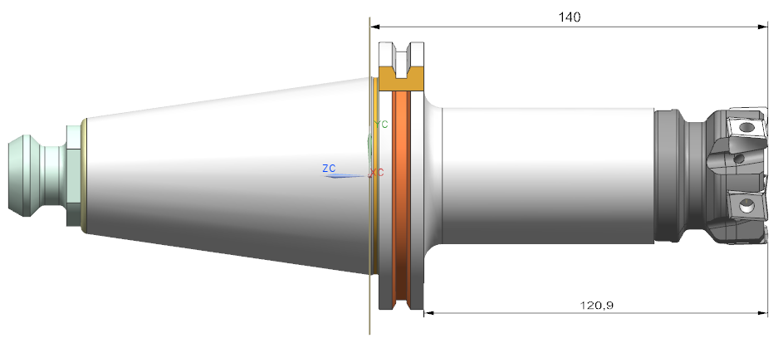
- end mill (item class 71E01A05D27A8)
  - weight = 2.457 kg
  - functional length (property 71DCD39338974) = 140 mm
  - usable length (property 71EBB33490FDA) = 120,9 mm
- manufacturer = Scania

Holder
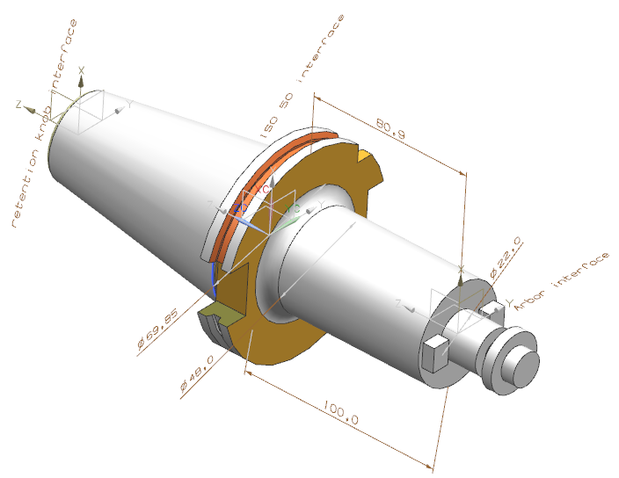
- converter (item class 71EAD3871D313)
  - weight = 2.127 kg

  - functional length (property 71DCD39338974) = 100 mm
  - usable length (property 71EBB33490FDA) = 80.9 mm
- variant 17 of SKG Steep taper (feature class 71EF22489E8A3)
  - connection code machine side (property 71D102AE3B252) = SKG17C0500$$$$
  - connection size code (property 71FC193318002) = 0500
    - side (property 71EBDBF130AE6) = mach
    - connection diameter (property 71EBDBF5060E6) = ⌀ 69.85 mm

- variant 21 of FDA milling arbor (feature class 71EF07FBDC4EF)
  - connection code workpiece side (property 71D102AE8A5A9) = FDA21G2200****
  - connection size code (property 71FC193318002) = 2200
    - side (property 71EBDBF130AE6) = wkps
    - connection diameter (property 71EBDBF5060E6) = ⌀ 22 mm

- manufacturer = Sandvik Coromant

Tool sub-assembly
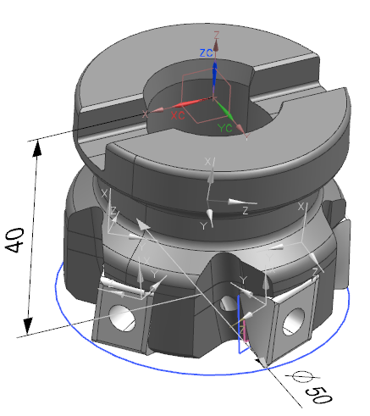
- end mill (item class 71E01A05D27A8)
  - weight = 0.33 kg
  - functional length (property 71DCD39338974) = 40 mm
- manufacturer = Scania

Tool body
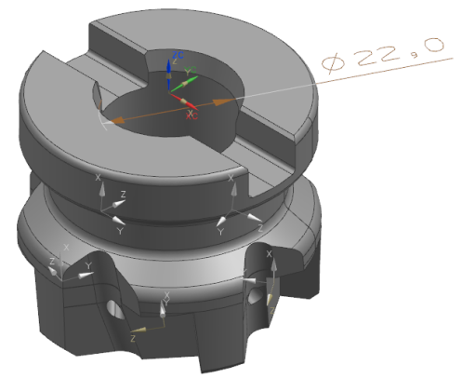
- end mill (item class 71E01A05D27A8)
  - weight = 0.31 kg
  - cutting diameter (property 71D084653E57F) = 50 mm
  - peripheral effective cutting edge count (property 71DCCFF75E485) = 5
  - cutting item count (property 71DF8C52B8926) = 5
  - cutting depth maximum (property 71CEAEBD5A66A) = 12.50 mm
  - functional length (property 71DCD39338974) = 40 mm
- variant 21 of FDA milling arbor (feature class 71EF07FBDC4EF)
  - connection code machine side (property 71D102AE3B252) = FDA21G2200$$$$
  - connection size code (property 71FC193318002) = 2200
  - side (property 71EBDBF130AE6) = mach
  - connection diameter (property 71EBDBF5060E6) = ⌀ 22 mm
- master insert (item class 71D0808DA853B)
  - master insert identification (property 71CF298FDE0EF) = ‘code of master insert’
  - corner radius (property 71DD6C8ACA503) = 0.8 mm
- insert interface code (property 71CE7A9936610) = ‘code matching tool and insert’

- manufacturer = ISCAR

Cutting insert
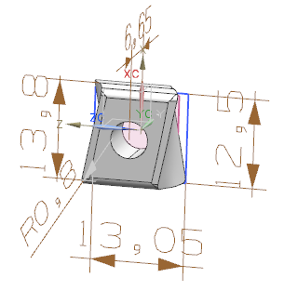
- parallelogram insert (item class 71DD68D966F52)
  - cutting edge count (property 71CEAE9B489F4) = 4
  - insert width (property 71CE7A9FB11C3) = 6.65 mm
  - insert length (property 71CE7A9DFA23A) = 13.80 mm
  - insert thickness (property 71CE7A9F5308C) = 13.05 mm

  - coating property (property 71DD703B84298) = TRUE
- rounded corner (feature class 71DD6C8A9985E)
  - corner radius (property 71DD6C8ACA503) = 0.8 mm

- manufacturer = ISCAR

Insert screw
No 3D geometry model
- manufacturer = Iscar

Retention knob
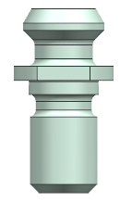
- manufacturer = unknown

Cutting tool classification

Assembly structure
Cutting tool assembly structure is done as defined for product structures in ISO 10303.

Tool classification

General property

Dimension property
Cutting tool dimensions are based on the common data structure for GD&T in ISO 10303 and share property representation together with a general property structure with reference to ISO 133399.

Feature classification

General feature representation
Representation of general_feature in line with to ISO 10303 is described in figure.
Figure. General feature representation in ISO 10303.

Feature classification
ISO 13399 feature classes are is assigned to general_feature in ISO 10303 data.
Representation of externally_defined_class.item_id e.g. IDENTIFIER('71ED66BA0F1F7') is the pointer to the class definition in ISO 13399.
Representation of externally_defined_class .name e.g. “variant 17 of SKG Steep taper” can optionally be used for explicit naming in the data set. It should not be used as the pointer to the class definition in ISO 13399. To simplify reading of a data set, the same name should be set for general_feature.name.
The same data structure applies for models without shape representation.
Figure. Connection interface feature class assignment

Structure of class and property representation

Class hierarchy
Within a dataset, externally_defined_class instances (for both items and features) are unique and reused as described in figure.
Figure. Class structure representation

Property name scope

