Minutes of WG3 T24 in Seoul
C.Sakamoto

[Attendants] :
C.Sakamoto, P.Muller, L.Slovensky, W.Gruttke, A.Crawford, D.Loffredo, F.Glantschnig, T.Vorburger, K.Yee, O.Nyqvist, S.Suh, F.Proctor, N.Swindle, T.Kishinami, C.Kouchi, M.Tsuchiya and others (24 peoples)

[Subjects] :
1. Confirmation of T24 Agenda in this week (Table 1)

Table 1 Schedule of WG3 T24

2. Report of Project Current Status (Monday 13:30-17:00)
2-1. ISO 14649 by F.Glantschnig
- Part 1 Overview and Fundamental Principles --- FDIS Ballot starts from 2002-11-21
- Part 10 General Process Data --- FDIS Ballot starts from 2002-10-31
- Part 11 Milling --- FDIS Ballot starts from 2002-11-14
- Part 111 Milling Tool --- FDIS Ballot starts from 2002-11-07
- Part 12 Turning --- NWI/CD ballot approved
- Part 121 Turning Tools --- NWI/CD ballot approved
- Part 13 Wire EDM --- NWI ballot not approved
- Part 14 Sink EDM --- NWI ballot not approved
- Candidates of New Projects
(1) Part 15 --- Wood and Glass Cutting Machine
(2) Part 16 --- Measuring Machine
(3) Part 17 --- Turning-Milling Center

2-2. ISO 13399 by O.Nyqvist
- New 13399 is composed of Tool Information model and Tool Catalogue model

2-3. AP219 by T.Vorburger
- Introduction of the new version of AP219

2-4. AP224.e3 by A.Crawford
- Revised schedule will be fixed in San Diego

2-5. AP238 by D.Loffredo
- NWI/CD ballot approved
- CD comments will be solved in this week

2-6. AP240 for Process Plan by L.Slovensky and C.Sakamoto
(1) Mapping tables were developed from UoFs
- 11 mapping tables created
(2) Mapping workshop held in Charleston, S.C.
- September 2002
- All ARM entities and attributes were mapped to Application Interpreted Model (AIM) elements
- There were no unresolved mapping issues

(3) Mapping philosophy
- There are two basic mapping methods
(a) Map ARM to integrated resources (IR)
- Do not subtype IR entities
- Write global rules to constrain IR entities to ARM requirements
(b) Map ARM to IR
- Subtype IR entities per ARM requirements
- Write local entity rules to constrain to ARM requirements
- This method is used for AP240
(4) AIM short listing developed
(5) AIM long form created
(6) Things to do:
- Develop global rules
- Edit document format
- Complete checklist for signoff
(7) Working draft document is being distributed at Seoul meeting.
(8) Committee Draft (CD) document to be sent to SC4 for CD ballot January 2003
(9) Roles of AP240 (Figure 1)

Figure 1 Roles of AP240

3. Discussion on AP238 CD Comments (Tuesday 8:00-17:00 and Thursday 13:00-17:00)

- Accepted as NWI and CD
  - 98 comments from 7 countries

CH-6, DE-13, JP-1, KR-24, SE-1, UK-2, US-39

- Comments can be classified into:
  - Precise verbiage for the scope statement
  - Relationship between ISO 14649 and AP-238
  - How information requirements are documented in AP-238
  - Choice of IR element for mapping
  - Editorial fixes

- All comments resolved

- After this meeting
  - Integrate comment resolutions
  - Begin preparation of DIS

［Distinction between AP-238 and AP-240］

- Agreement was finally reached

- Out of scope statement for AP-238
  - description of manufacturing activities not related to automatic execution by a computerized numerical controller.

- Out of scope statement for AP-240
  - NC program, source programs, and specific machine tool controller codes;
  - actual execution of the process plan or associated NC programs.

4. AP219 Review (Wednesday 10:30-12:00)
- Introduction of the Test Part for AP219 (Figure 2)
- The New Scope of AP219
[Scope and Functional Requirements as Stated in the PWI］
This Application Protocol (AP) will specify information requirements to manage dimensional inspection of solid parts or assemblies, which includes administering, planning, and executing dimensional inspection as well as analyzing and archiving the results.
- Manufacturing Feature Data Model(AP224) is added.
- Develop materials and resolution for submission as New Work Item to SC4 February FY03 Meeting

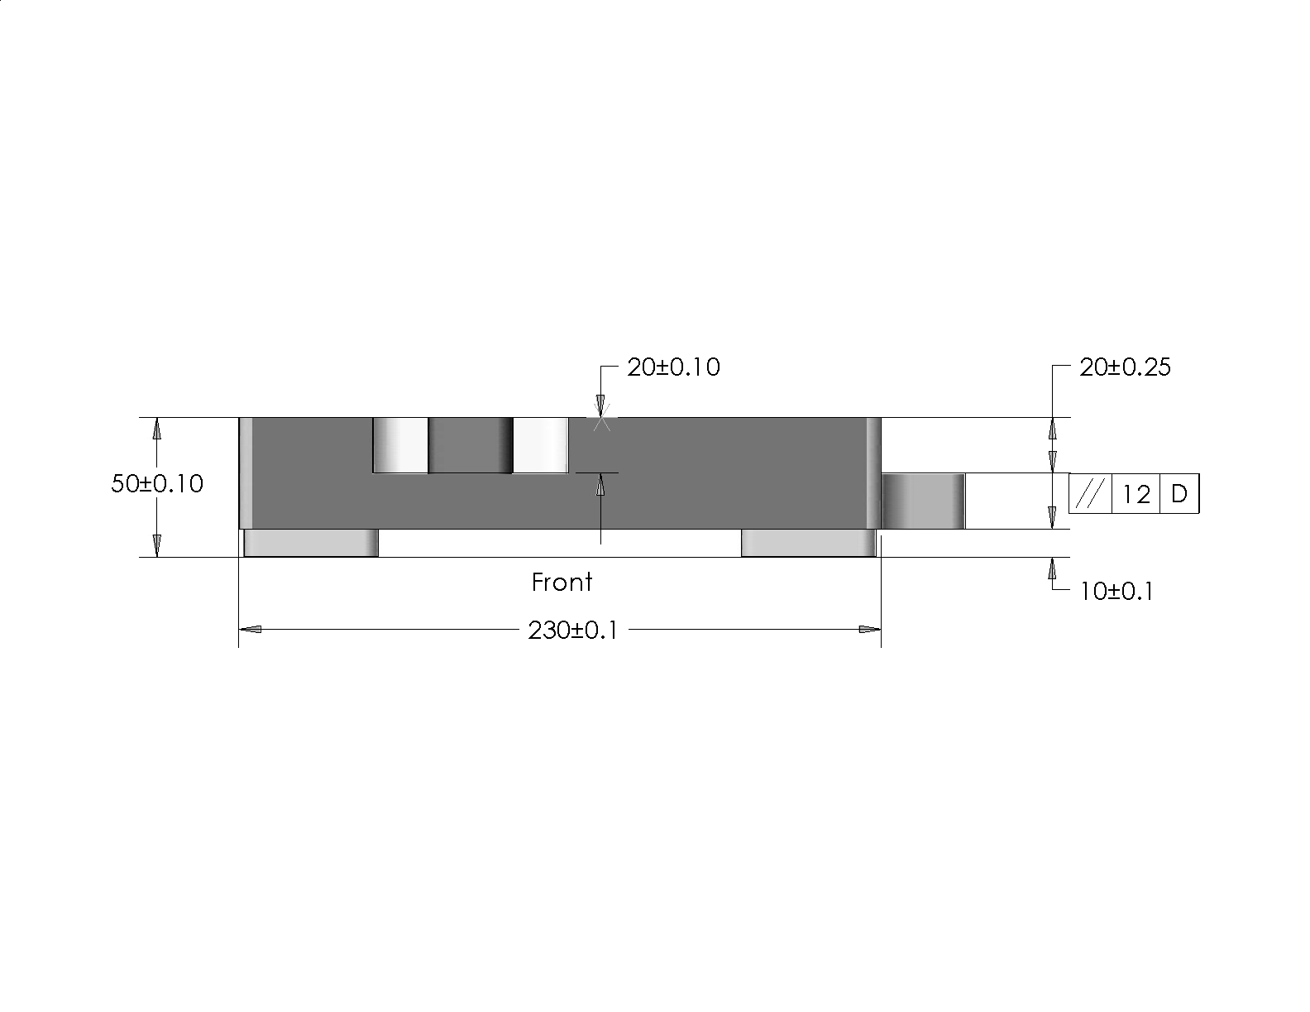

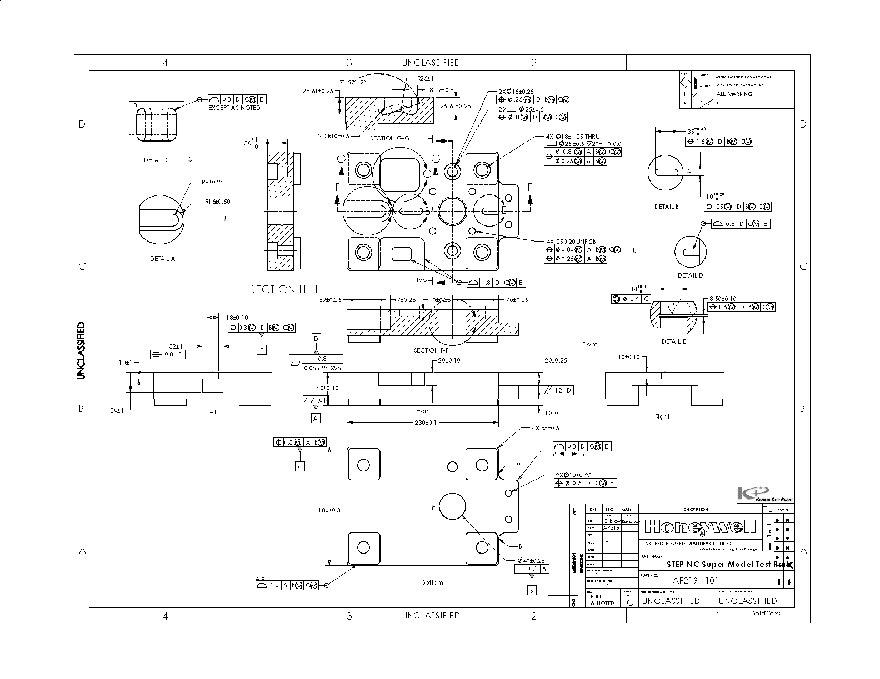

Figure 2 Test Part for AP219

5. AP240 Review (Wednesday 13:00-15:00 and Thursday 10:30-12:00）
- Explanation of the relationship between ARM entities and AIM entities (Figure 3)
[Process Activities ARM entities]
-Activity -Allowed_time -Alternate_activity -Ancillary_setup -Fixture_setup
-General_machining_operation -Generic_manufacturing_resource -General_setup_process
-Integrated_controler_setup -Machine_setup -Machining_process -Machine_usage
-Manufacturing_activity -Manufacturing_process -Non_machining_process
-Part_fixture_mounting -Part_fixture_unmounting -Part_handling -Part_loading
-Part_machine_mounting -Part_machine_unmounting -Part_unloading -Performance_rate
- Production_rate -Process_activity -Resource_with_material -Resource_with_representation
-Setup_activity -Single_setup_process -Tool_setup -Validation
[Process Activities AIM entities]
Figure 3 Relationship between ARM entities and AIM entities

- Links from AP240
AP224, AP240, and AP238 need to work in harmony
to satisfy requirements for the manufacture of
machined parts.
AP240 provides input to AP238 AP240 ＡP238
6. Harmonization between ISO 13399 and ISO 14649 (Wednesday 15:30-17:00)
- Introduction of New ISO13399 by N.Swindle
- Discussion on the Harmonization Methods
- Conclusion
TC29/WG34 will send the latest information of ISO13399 to SC1/WG7. Then SC1/WG7 will find items which need to harmonize between ISO13399 and ISO14649.
Those items will be discussed in the San Diego meeting.

7. Joint Meeting with T23(Ship) (Thursday 8:00-10:00)
- Introduction of Plate Cutting and Pipe Bending by D.Loffredo
- Introduction of AP240 by L.Slovensky
- Joint Meeting will be held in San Diego

--------------------------------------------------------------------------------------------------------------------------
[Meeting Requests of T24 in San Diego]
- 2 sessions for AP219
- 2 sessions for AP240
- 1 session for Harmonization between ISO 13399 and ISO 14649
- 1 session for Joint Meeting with T23(Ship)

[Task for T24]

Resolution N in Seoul – Comparative assessment of ISO 14649 and ISO 10303-238
SC4 notes resolution 145 of SC1 and requests SC1 to ensure adequate representation of SC4 development activities within the proposed studies, noting the existing participation of SC4 experts in SC1 meetings.

SC4 requests WG3/T24 experts to report on the status of this activity at the SC4 meeting in San Diego in March 2003, and give initial recommendation on the necessary convergence between AP238 and ISO 14649.

End

・Peter Müller of Siemens (Germany) (the chair of SC1)
・Meinolf Gropper (Germany) (the secretary of SC1)
・Stefan Heusinger of ISW Stuttgart (Germany)
・Yong Tak Hyun of the WZL/University of Aachen (Germany)
・Masanori Kunieda of Tokyo University of Agriculture & Technology (Japan)
・Chiaki Sakamoto of Manufacturing Engineering Research (Japan)
・Suk-Hwan Suh of NRL-SNT (Korea)
・Byeong-Eon Lee (Korea)
・Dae-Jung Seong (Korea)
・Tae-Weon Gim (Korea)
・Suk-Hwan Suh (Korea)
・Eung-Suk Lee (Korea)
・Injun Choi (Korea)
・Olof Nygvist (Sweden)
・Friedrich Glantschnig of AMT Consulting (Switzerland)(the chair of WG7)
・Nguyen Van Khai (Switzerland)
・Fred Proctor of NIST (US)
・Len Slovensky of SCRA(US)
・William Gruttke of SCRA(US)
・Martin Hardwick of STEP Tools, Inc. (US)
・David Loffredo of STEP Tools, Inc. (US)
・Carol Tierney of Fluid Dynamics (US)
他２名

